Membership Newsletter

**August 1, 2015**

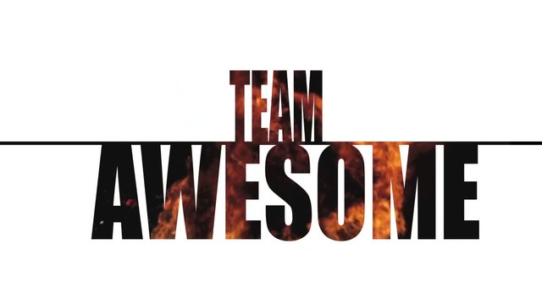

***There’s No Excuse...Just Recruit***

Ladies,

This year Membership program is going to embark down a new road,

1. We will now accept the applications of males. (August 22nd )
2. We will work hard to help reverse the declining member number.

With that we will be a stronger team to help our Veterans and their families.

Accepting Applications of Males..

I know there are a lot of questions about allowing males into the auxiliary, here is what I know so far.

1. Applications can’t be accepted till August 22nd.
2. The application process is the same, fill out an application, eligible DD214, voted on at meeting, payment of dues.
3. Application is the same until national send out a new form.
4. The men’s auxiliary will STAY intact this is NOT a merger of the two males simply have a choice

**Department Award**

Reach: 80% By Sept. 30th 2015 Receive $250

Reach: 90% By Dec. 31st 2015 Receive $300

Reach: 95% By Mar 31st 2016 Receive $500

Reach: 100+% By May 31st 2016 Receive $1,000

Reach: 101+% By June 30th 2016 Receive additional $500

**Member Awards**

**No Excuse….I Recruit Pin**

**Given to each auxiliary and vfw member who secures 5 new not rejoined members by May 31, 2016. (Treasures not eligible)**

**National membership achievement award**

1. **given to the auxiliary or vfw member that secures 20 new not rejoined members from july 1, 2015 to april 30, 2016 (treasurers not eligible)**
2. **Given to the auxiliary or vfw member that secures 40 new not rejoined members from july 1, 2015 to april 30, 2016 (treasurers not eligible)**

**Symbol of service award**

**Awarded to only one auxiliary member who recruits the most new not rejoined members by may 31, 2016 will receive a “symbol of service” award with members name on it alongside the name of an honored veteran.**

**Message for membership program**

**There’s no excuse….Just recruit**

This yeAR THE NATIONAL MEMBERSHIP AMBASSADOR IS ASKING EVERYONE TO RECRUIT JUST ONE NEW MEMBER……1 that’s IT.

i BELIEVE dEPT. OF aLASKA CAN NOT ONLY MEET THAT CHALLENGE BUT EXCEED IT.

mEMBERSHIP pROGRAM GOALS:

1. rECRUIT NEW MEMBERS
2. RETAIN CURRENT MEMBERS
3. GROW THE ORGANIZATION

nO eXCUSE…….jUST RECRUIT

oUR vETERANS NOW AND FOREVER



Mistie Hammond

Membership Ambassador

Department of Alaska

1430 E 14th

Anchorage, Alaska 99501

mistie@awanatravel.com